**BEEE309L - Microprocessors and Microcontrollers**

**Review zero**

1. **Name of the Project: GSM based Transformer Fault Detection System**
2. **Slot: E2**

**Abstract:** Transformers are essential components in power transmission and distribution systems, ensuring reliable and efficient energy delivery. To enhance their performance and longevity, it is crucial to monitor transformers for potential issues before they escalate into costly repairs and service interruptions. This project focuses on developing an innovative system to monitor voltage, current, temperature, and oil level in transformers using GSM technology. The system is designed to provide real-time alerts and protection based on these critical parameters. Utilizing Proteus software, a virtual transformer model was created to facilitate accurate voltage and current measurements, detect overloading and no-load conditions, and calculate oil level and temperature. Additionally, a hardware model will be developed to implement and test the monitoring system in a real-world scenario. By integrating remote monitoring capabilities through GSM, the system ensures prompt detection of anomalies, enhancing maintenance strategies and reducing downtime. This approach not only improves the operational efficiency of transformers but also contributes to the overall stability of the electrical power network.

1. **Block Diagram:**

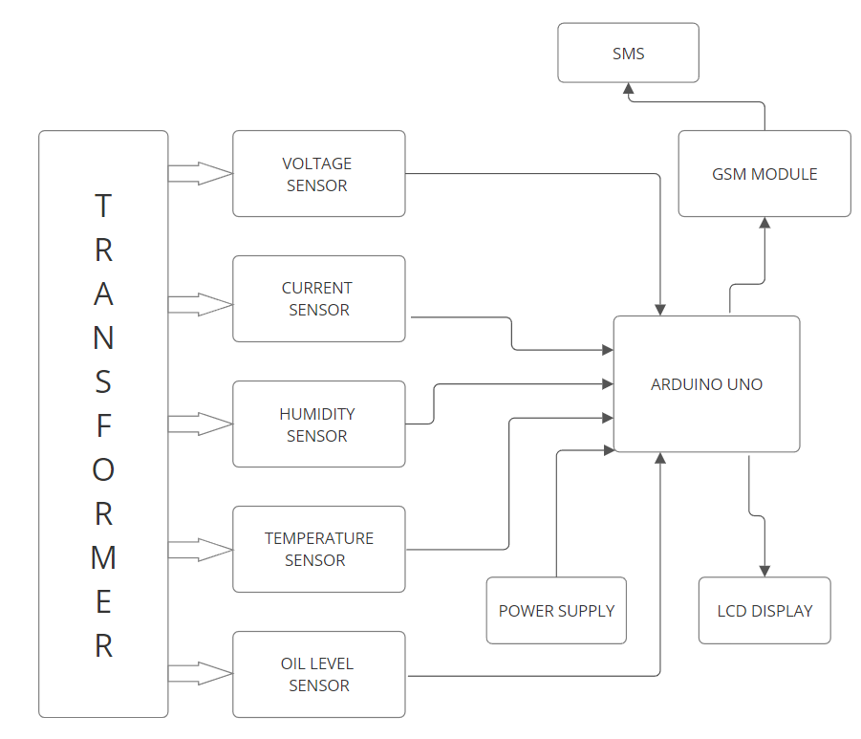

1. **Outcome expected:**

To detect the transformer fault automatically using sensors.

To convey information automatically to control room for further corrective reaction.

To shorten the response time in order to free transformers from break occurs on large amount of power transmitted.

To maintain better stableness, accuracy and safety for the system in the country.

1. **Batch members contribution:**

|  |  |  |
| --- | --- | --- |
| **Reg. No.** | **Name** | **Nature of Work** |
| **22BEE1292** | **Ayush Kumar** | **Hardware assembly** |
| **22BEE1313** | **Tanmay Rawat** | **Software/Simulation** |

1. **Source :**

[**https://youtu.be/hmmBhZaGkqc?si=BKEXwJM-Mluej8Kt**](https://youtu.be/hmmBhZaGkqc?si=BKEXwJM-Mluej8Kt)

[**https://www.irjet.net/archives/V9/i7/IRJET-V9I752.pdf**](https://www.irjet.net/archives/V9/i7/IRJET-V9I752.pdf)